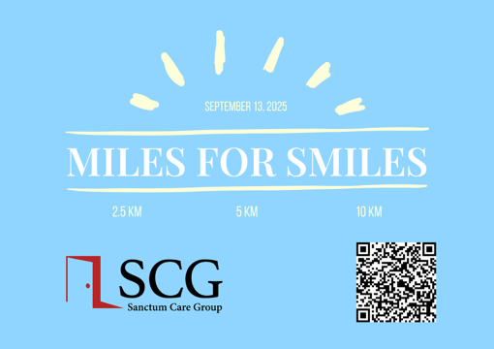
MILES FOR SMILES PLEDGE FORM

I am running/walking in the 22nd Annual Miles for Smiles Fundraiser on Saturday, September 13th, 2025

I, ______________________________________, am asking for your support to raise funds for Sanctum Care Group. All the money you pledge for our run/walk will be donated to Sanctum Care Group. Sanctum Care Group is an NGO (non-governmental organization) formed in 2015. Sanctum provides care for people living with HIV, or at-risk of acquiring HIV, that is dignified, non-judgmental and unconditional. SCG facilitates individualized and contextualized care for complex patient populations in collaboration with community partners through trauma informed, culturally responsive and evidence-based interventions.
Please ensure cheques are made out to: Student Medical Society of Saskatchewan

NAME | ADDRESS | CITY/PROVINCE/POSTAL CODE | EMAIL | PHONE # | DONATION



THANK YOU FOR YOUR SUPPORT & DONATION!
Smss.fundraisingrep@gmail.com

All donations are made payable to:
Student Medical Society of Saskatchewan
College of Medicine, 3A20 Health Sciences Building
107 Wiggins Road
Saskatoon, SK S7N 5E5
OR e-transfer treasurer.smss@gmail.com, and include Miles for Smiles 2025 donation in the subject

Runners can bring their form and donations to the event or contact smss.fundraisingrep@gmail.com for alternate arrangements!

