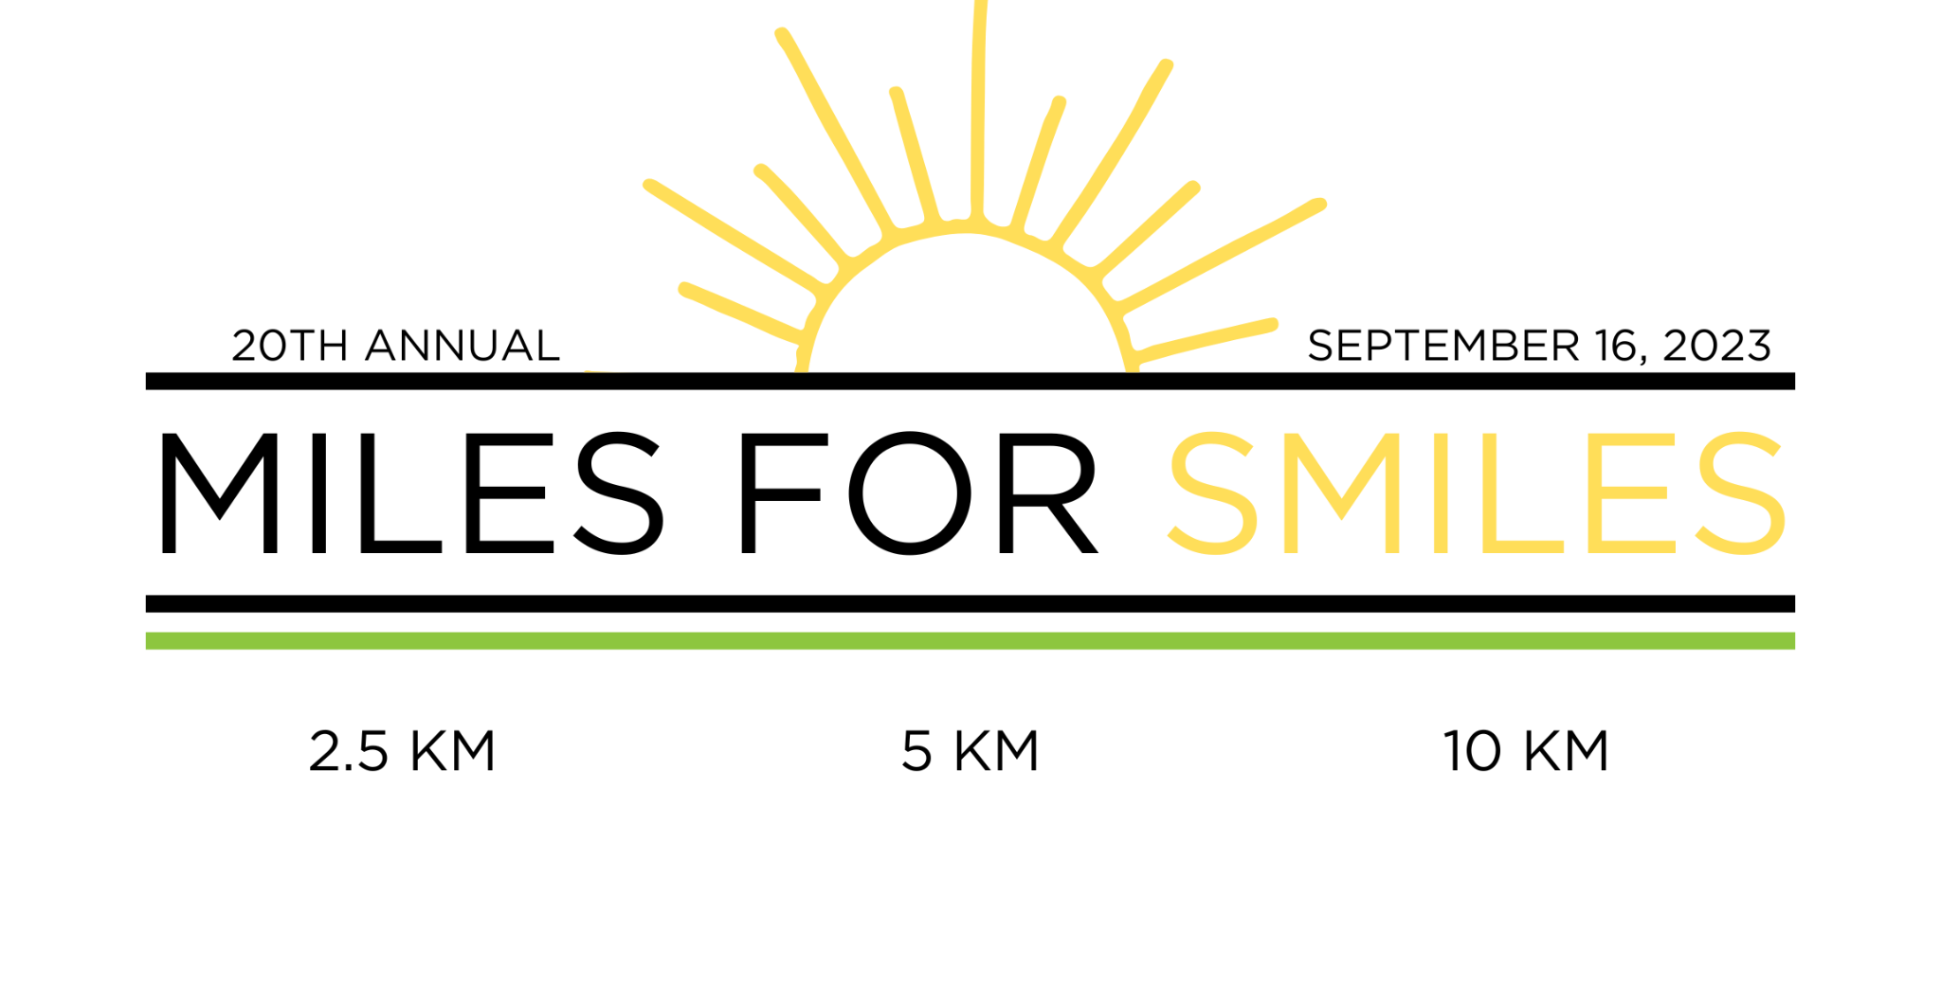

MILES FOR SMILES PLEDGE FORM

I am running/walking in the 20th Annual Miles for Smiles Fundraiser on Saturday, September 16th, 2023

I, ______________________________________, am asking for your support to raise funds for SaskAbilities. All the money you pledge for our run/walk will be donated to SaskAbilities, an organization working together to build inclusive communities for people of all abilities. Initiatives within the organization include provided accessible parking, orthopedics and equipment, assessment services, and community programs. One of SaskAbilities most impactful contributions to healthcare is their work providing mobility aids to those in need, which would otherwise cost thousands of dollars. These mobility aids help give people the dignity and quality of life that they otherwise would not be able to afford.

Please ensure cheques are made out to: Student Medical Society of Saskatchewan

NAME | ADDRESS | CITY/PROVINCE/POSTAL CODE | EMAIL | PHONE # | DONATION
THANK YOU FOR YOUR SUPPORT & DONATION!
Smss.fundraisingrep@gmail.com

Runners can bring their form and donations to the event, or mail to:
ATTN: Miles for Smiles
c/o Brynne Stebbings
2248 Halifax Street,
Regina, SK, S4P 1V2

