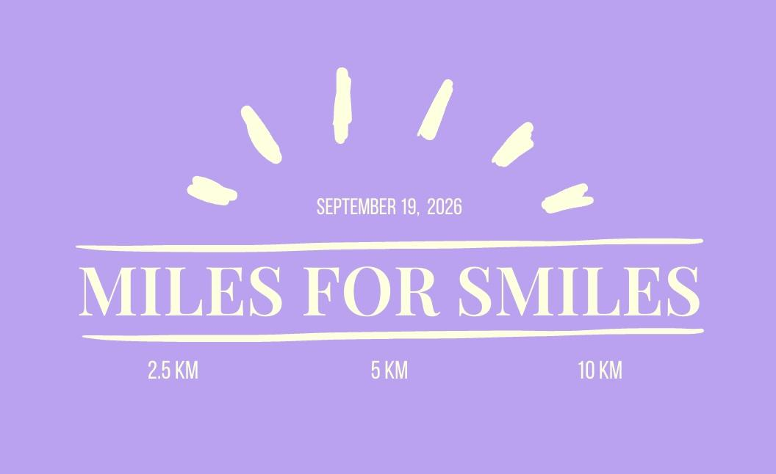

Miles for Smiles Pledge Form

I am running/walking in the 23rd Annual Miles for Smiles Fundraiser on Saturday, September 19th, 2026

I, ______________________________________, am asking for your support to raise funds for Alzheimer Society of Saskatchewan. All the money you pledge for our run/walk will be donated to Alzheimer Society of Saskatchewan. This is an organization working in dementia care and research. They offer crucial services to individuals and families affected by Alzheimer's Disease through services and programs, empowerment, education, and advocacy. Over 65% of the funding comes directly from donors which allows support for individuals and families affected by dementia. Through a community-based approach, the Alzheimer Society offers Help for Today and Hope for Tomorrow.
Please ensure cheques are made out to: Student Medical Society of Saskatchewan

NAME | ADDRESS | CITY/PROVINCE/POSTAL CODE | EMAIL | PHONE # | DONATION



THANK YOU FOR YOUR SUPPORT & DONATION!
Smss.fundraisingrep@gmail.com

All donations are made payable to:
Student Medical Society of Saskatchewan
College of Medicine, 3A20 Health Sciences Building
107 Wiggins Road
Saskatoon, SK S7N 5E5

Runners can bring their form and donations to the event, or mail to:
ATTN: Miles for Smiles
c/o Jordan Reekie
319 Beckett Green.
Saskatoon, SK,
S7N 4W7

