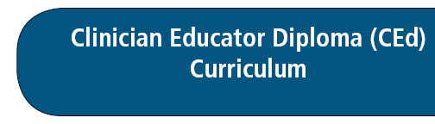


Version 2: June 11, 2025 (USask)

Personal Learning Plan (Foundations Capstone)

Complete a personal learning plan that discusses how you will continue to grow as a clinician educator in an area not covered by your CEd training to date.

Please write a brief (500 word) response to the following questions. Discuss your responses with your Foundations Unit advisor. Modify your initial responses to reflect any changes that result from the discussion.

- What is your identified learning need and how did you determine this learning need?
- What learning methods/strategies will you pursue and why?
- How will you evaluate the success of your plan?
- Describe the system you will use to track and record your learning needs in the future (e.g. learning management system).

